
GENEGUIDE AI: AI-BASED PRENATAL GENETIC RISK ASSESSMENT AND DECISION SUPPORT SYSTEM
THIRD YEAR
MINI PROJECT REPORT
Submitted by
MOHAMED ISMAIL – 24623118
VEERAPUVIN S – 24623155
SAKTHIBALAN G – 24623145
in Partial fulfillment of the requirements for the award of the degree of
BACHELOR OF TECHNOLOGY IN CSE
ARTIFICIAL INTELLIGENCE

DEPARTMENT OF ARTIFICIAL INTELLIGENCE AND MACHINE LEARNING
SCHOOL OF ENGINEERING
VELS INSTITUTE OF SCIENCE, TECHNOLOGY AND ADVANCED STUDIES (VISTAS)
CHENNAI – 600 117
NOVEMBER 2026
BONAFIDE CERTIFICATE
Certified that this project report “GENEGUIDE AI: AI-BASED PRENATAL GENETIC RISK ASSESSMENT AND DECISION SUPPORT SYSTEM”, is the Bonafide work of MOHAMED ISMAIL - 24623118, VEERAPUVIN S - 24623155, SAKTHIBALAN G - 24623145 who carried out the project under my supervision. Certified further, that to the best of my knowledge the work reported here does not form part of any other project report or dissertation on the basis of which a degree or award was conferred on an earlier occasion on this or any other candidate.
SIGNATURE OF THE HOD  Dr. K. Ulaga Priya M.E., Ph.D  Associate Professor & Head  Department of AI&ML  School of Engineering  VISTAS  Chennai | SIGNATURE OF THE SUPERVISOR  Ms. F. Benasir Begam M.E., (Ph.D)  Assistant Professor  Department of AI&ML  School of Engineering  VISTAS  Chennai

Submitted for the Project Work and Viva-Voce examination held on……………
at Vels Institute of Science, Technology and Advanced Studies (VISTAS), Chennai – 600 117.
INTERNAL EXAMINER | EXTERNAL EXAMINER

DECLARATION
We hereby declare that the mini project report entitled "GENEGUIDE AI: AI-BASED PRENATAL GENETIC RISK ASSESSMENT AND DECISION SUPPORT SYSTEM", submitted to Vels Institute of Science, Technology and Advanced Studies (VISTAS), Chennai, in partial fulfillment of the requirements for the award of the degree of Bachelor of Technology in Computer Science and Engineering (Artificial Intelligence), is a record of original work carried out by us under the guidance of Ms. F.Benasir Begam M.E, (Ph.D.), Assistant Professor, Department of Artificial Intelligence and Machine Learning. The work has not been submitted, in part or in full, for the award of any other degree or diploma.

Place: Chennai
Date: 30.10.2026

Mohamed Ismail – 24623118
Veerapuvin S – 24623155
Sakthibalan G – 24623145

ACKNOWLEDGEMENT
It is certainly a great delight and proud privilege to acknowledge the help and support we received from the positive minds around us in making this venture a successful one. The infrastructural support with all kinds of lab facilities has been a motivating factor in the completion of this project work, all because of our FOUNDER & CHAIRMAN, Shri. Dr. ISHARI K. GANESH, and it is with great pleasure that we take this opportunity to thank him. We are grateful to our HEAD OF THE DEPARTMENT, Dr. K. Ulaga Priya, for her continuous support for the project, from initial advice and contacts in the early stages of conceptual inception, and through on-going advice and encouragement to this day. We extend our warmest thanks to our INTERNAL GUIDE, Ms. F. Benasir Begam, Assistant Professor, Department of AI&ML, who has patiently guided us and provided invaluable advice and help. We would like to express our greatest gratitude to our staff members, Librarian, and Non-teaching staff members of the Computer Centre, who have helped and supported us throughout. Last but not the least, we wish to thank our parents and our friends for their individual support and interest, who have inspired and encouraged us to go our own way. Without them we would be unable to complete this project.
MOHAMED ISMAIL - 24623118
VEERAPUVIN S - 24623155
SAKTHIBALAN G - 24623145

CHAPTER NO. | TABLE OF CONTENT | PAGE NO.
 | ABSTRACT | i
 | LIST OF FIGURES | ii
 | ABBREVIATIONS | iii
1 | INTRODUCTION | 1
 | 1.1 Overview of the project | 1
 | 1.2 Scope and objective | 3
2 | LITERATURE REVIEW | 7
 | 2.1 Literature Overview | 7
 | 2.2 Literature Survey | 7
3 | SYSTEM DESIGN | 10
 | 3.1 Existing System | 10
 | 3.2 Proposed System | 10
 | 3.3 System Architecture | 11
 | 3.4 Hardware Requirements | 12
 | 3.5 Software Requirements | 13
4 | IMPLEMENTATION | 14
 | 4.1 Methodology | 15
 | 4.2 Implementation | 16
 | 4.2.1 Authentication Module | 16
 | 4.2.2 Assessment Form Module | 16
 | 4.2.3 Risk Prediction Module | 16
 | 4.2.4 Result Module | 17
 | 4.2.5 History Module | 17
5 | CONCLUSION AND FUTURE WORK | 18
 | 5.1 Conclusion | 18
 | 5.2 Future Work | 18
 | 5.3 Source Code | 19
 | 5.4 Results | 28
 | APPENDIX A- CONFERENCE PAPER CERTIFICATES | 32
 | REFERENCES | 33

ABSTRACT
Prenatal genetic risk assessment helps identify pregnancies that may carry an increased likelihood of inherited genetic disorders. Today this usually means a doctor reviews family history, parental details and past pregnancy results one by one, which is slow and difficult when genetic counsellors are not nearby. This project presents GeneGuide AI, a web-based decision-support prototype that estimates prenatal genetic risk from parental, family-history and pregnancy information. A Random Forest classifier trained on a synthetic, medically informed dataset of 1,250 records with 14 input features places each assessment into one of three groups: Low, Moderate or High risk. The result is intended to be educational, not a diagnosis, and every result page states this. The system is built with Python, Flask, Scikit-learn, SQLite, HTML, CSS and JavaScript. It includes user registration and login, a validated multi-section assessment form, and a saved history of past assessments for each user. On a held-out test set of 250 records the model achieved 85.2 percent accuracy, with F1-scores of 0.92 for Low, 0.87 for Moderate and 0.75 for High risk, and it never confused Low risk with High risk. GeneGuide AI shows how machine learning combined with an easy-to-use web interface can make early risk screening more accessible, while still encouraging users to consult qualified doctors for final decisions.
Keywords: Prenatal genetic risk, Random Forest, machine learning, decision support system, risk classification, Flask, synthetic dataset, explainable AI.
LIST OF FIGURES
FIGURE NO | TITLE | PAGE NO.
Figure 1 | Proposed system architecture of GeneGuide AI | 12
Figure 2 | Class distribution of the dataset | 16
Figure 3 | Training output (accuracy, classification report, confusion matrix) | 32
Figure 4 | Confusion matrix on the 250-record test set | 33
Figure 5 | Home page of GeneGuide AI | 34
Figure 6 | Login page | 34
Figure 7 | Assessment form | 35
Figure 8 | Result page | 35
ABBREVIATIONS
Abbreviation | Full Form
AI | Artificial Intelligence
ML | Machine Learning
RF | Random Forest
API | Application Programming Interface
CSS | Cascading Style Sheets
CSV | Comma-Separated Values
GUI | Graphical User Interface
HTML | Hypertext Markup Language
HTTP | Hypertext Transfer Protocol
JS | JavaScript
PKL | Python Pickle (serialized model file)
RAM | Random Access Memory
SQL | Structured Query Language
F1 | F1-score (harmonic mean of precision and recall)
UG | Under Graduate
VISTAS | Vels Institute of Science, Technology & Advanced Studies

CHAPTER 1. INTRODUCTION
1.1 OVERVIEW OF THE PROJECT
Introduction
Prenatal care often begins with collecting family-history, demographic and screening information to judge whether a pregnancy carries a higher genetic risk. A clinician usually makes this judgment by hand, weighing factors such as maternal age, consanguinity, carrier status and earlier pregnancies against experience and published risk tables. The approach works, but it takes time, it depends on how familiar the individual clinician is with the material, and it is hard to scale where genetic counsellors are few.
Machine learning can formalize part of this reasoning. A classifier trained on risk factors and outcomes gives a consistent, repeatable risk category for any combination of inputs. GeneGuide AI pairs such a classifier, a Random Forest trained on a synthetic, medically informed dataset of fourteen prenatal and family-history features, with a complete web application, so that the prediction sits inside a tool people can actually use from start to finish.
GeneGuide AI is scoped clearly as an educational prototype. It relies on synthetic data rather than real patient records, and every output is presented as an AI-generated risk category to be discussed with a qualified healthcare professional, never as a diagnosis.

Problem Statement
Genetic risk assessment usually requires a doctor or counsellor to review many pieces of information together. This has several drawbacks:
• Complexity: Prenatal genetic risk depends on many factors at once, and weighing them by hand is complex and time-consuming.
• Scattered information: Family history and previous pregnancy details are hard to evaluate together.
• Interpretation: Genetic screening information needs proper interpretation, which is not always available nearby.
• Access: Genetic counsellors are few, so many families have no easy way to understand their risk factors early.
The core problem is the lack of a simple tool that organizes these factors and gives an understandable, preliminary risk category. The question addressed by this project is: how can machine learning combine selected prenatal, family-history and genetic factors to give an understandable prenatal genetic risk assessment?
Objectives of the Project
• To develop an AI-based prenatal genetic risk assessment system.
• To analyze selected maternal, paternal, pregnancy, family-history and genetic factors.
• To use a Random Forest model to classify risk as Low, Moderate or High.
• To give understandable information about the factors behind the prediction.
• To build a user-friendly, web-based decision-support prototype.
Scope of the Project
The system is designed as an assistive, educational tool, not a replacement for medical professionals. Its scope covers:
• Risk assessment: a 14-field questionnaire on parents, family history and pregnancy, classified into Low, Moderate or High.
• User accounts: registration, secure login and a private history for every user.
• Explanation: a result page that says why the result may have occurred and carries a medical disclaimer.
• Applicability: awareness and preliminary screening for families, students and training of healthcare learners.
System Overview
The system integrates three major components:
1. Machine learning model: a Random Forest classifier with 200 trees, trained offline on the synthetic dataset and saved with joblib.
2. Web application: a Flask server that validates the inputs, encodes them with the saved encoders and returns the predicted risk category.
3. Database: a SQLite database that stores user accounts and each user’s past assessments.
Advantages of the System
• Accessible: available from any browser, so risk screening does not depend on a counsellor being nearby.
• Consistent: the same inputs always give the same risk category.
• Quick: the result appears immediately after the form is submitted.
• Private: passwords are stored only as hashes and each user sees only their own history.
• Safe by design: every result states that it is educational and not a diagnosis.
Applications of the Project
• Awareness: helping families understand which factors influence prenatal genetic risk.
• Education: teaching students how machine learning is applied to healthcare screening.
• Pre-counselling: helping a user organize family and pregnancy details before meeting a doctor.
• Research prototype: a base for testing other models and explanation methods on prenatal risk data.
Expected Outcomes
• A working web prototype with login, a validated form, prediction, result page and history.
• A trained Random Forest model that separates Low, Moderate and High risk categories with measured accuracy.
• A report of precision, recall, F1-score and the confusion matrix on unseen test data.
• A foundation for adding explainability and model comparison in later work.
1.2 SCOPE AND OBJECTIVE
Purpose of the Study
The main purpose of this project is to design, implement and evaluate an AI-assisted prenatal genetic risk assessment tool that supports preliminary screening. It aims to achieve:
1. Analysis of parental, family-history and pregnancy factors together instead of one at a time.
2. A consistent Low, Moderate or High risk category produced by a trained machine learning model.
3. A simple web interface that anyone can use without special training.
General Objective
The general objective is to create a reliable, easy-to-use system that organizes prenatal genetic risk factors and gives an understandable risk category, while clearly stating that it is an educational prototype and encouraging users to consult qualified professionals.
Specific Objectives
• To prepare a synthetic, medically informed dataset of 1,250 records with 14 input features and a Risk_Level target.
• To encode the categorical features with LabelEncoders and save them for use at prediction time.
• To train a Random Forest classifier on 1,000 records and test it on 250 unseen records.
• To evaluate the model with accuracy, precision, recall, F1-score and a confusion matrix.
• To build a Flask application with registration, login, a validated assessment form and a result page.
• To store every assessment in SQLite so each user can review their own history.
Scope of the Project
A. Functional Scope
• User accounts: registration and login with hashed passwords; protected pages.
• Assessment form: 14 inputs in three sections with range checks on the numbers.
• Prediction: the inputs are encoded and classified as Low, Moderate or High.
• Result and history: the result page shows the risk level and the likely reasons; every assessment is saved.
B. Technical Scope
• Frontend: HTML, CSS and JavaScript with Jinja2 templates.
• Backend: Python with the Flask framework.
• Database: SQLite with parameterized queries.
• Libraries: Pandas and NumPy for data handling, Scikit-learn for the model, Joblib for saving the model and encoders, Matplotlib for the confusion matrix.
C. Application Scope
• Awareness and preliminary screening for families.
• Education and demonstration in classrooms and workshops.
• Pre-counselling preparation before a visit to a doctor.
Importance of the Project
Early understanding of genetic risk factors lets families plan screening, counselling and preventive care sooner. By turning a long manual review into a short questionnaire, GeneGuide AI lowers the barrier to starting that conversation. It does not replace the doctor; it helps people arrive better informed.
System Functionality Overview
1. Registration and login: a user creates an account and signs in.
2. Data entry: the user completes the 14-field assessment form.
3. Validation: the server checks that every number is in a plausible range.
4. Encoding: categories are converted with the same encoders used in training.
5. Prediction: the Random Forest returns Low, Moderate or High.
6. Result and storage: the result page is displayed and the assessment is saved to the user’s history.
Methodology for Achieving Objectives
1. Requirement analysis: identify the factors that influence prenatal genetic risk.
2. Data preparation: build and check the synthetic dataset.
3. Model training: encode features, split the data 80/20 and train the Random Forest.
4. Evaluation: measure accuracy, precision, recall, F1-score and the confusion matrix.
5. Application development: build the Flask web application and database.
6. Testing: check the form, prediction and history modules with sample inputs.
Challenges and Limitations
• The training data is synthetic, not real patient records.
• With 1,250 records, the boundary between High and Moderate risk cannot be learned finely.
• There is no clinical validation; accuracy is measured on a split of the same synthetic data.
• Inputs far outside the training range may give unreliable results without a warning.
• The tool must be presented carefully so that it is never mistaken for a diagnosis.
CHAPTER 2. LITERATURE REVIEW
2.1 LITERATURE OVERVIEW
Machine learning has been applied to many parts of pregnancy care, from first-trimester screening to fetal health monitoring and from polygenic risk scoring to clinical decision support. Most published systems are built and judged as models, using clinically measured data such as ultrasound markers, serum biochemistry or genotype data. Far fewer are delivered as a tool an ordinary user can operate.
This review covers twelve sources on machine-learning-based prenatal, genetic and fetal risk assessment, clinical decision support and family-history risk tools. It serves the following purposes:
• To identify the research gap that a questionnaire-based, self-administered prenatal risk tool can fill.
• To understand which models and data types earlier studies used.
• To justify the choice of a Random Forest classifier for a small tabular dataset.To provide the theoretical foundation for the proposed system.
2.2 LITERATURE SURVEY
The survey is organized into thematic sub-sections, from clinical decision support to family-history tools.
A. Machine Learning in Clinical Decision Support
Putting predictive models directly into clinical workflows has been a major research theme for about a decade. A 2023 scoping review of machine-learning-based clinical decision support by Susanto et al. found that most published systems are judged only on offline model accuracy, and far fewer studies check whether a deployed system changed decisions, care delivery or patient outcomes [9]. This gap between a model and a deployed system shapes this project: the Random Forest is just one part of a larger authenticated web application.
B. Ensembling Polygenic and Non-Genetic Risk Factors
Yuan et al. built DBNX, a pipeline that first merges thirteen separately computed polygenic risk scores using an unsupervised Deep Belief Network, then adds non-genetic variables such as age and lifestyle through XGBoost to give one Composite Risk Score [1]. It was tested on four adult diseases using U.K. Biobank cohorts. DBNX needs genome-wide genotyping data and biobank-scale cohorts, which a questionnaire-based prototype does not have. GeneGuide AI instead uses reported family and obstetric history in place of measured genetic variants, giving up fine-grained resolution in return for accessibility.
C. Neural-Network-Based First-Trimester Aneuploidy Screening
Neocleous, Nicolaides and Schizas published two related studies that apply feed-forward artificial neural networks to first-trimester aneuploidy screening. Their inputs are clinically measured markers such as maternal age, crown-rump length, PAPP-A, free β-hCG and nuchal translucency. The first study, trained on 51,208 pregnancies, reports a nine-marker network that found every Trisomy-21 case in its evaluation set at a 3.9% false positive rate [2]. The follow-up study used datasets covering over 122,000 pregnancies and compared raw marker values with normalized values on a highly imbalanced dataset [3]. These systems rely on measurements taken in a clinic, unlike the questionnaire inputs used here.
D. Cascaded and Ensemble Methods for Imbalanced Screening Data
Li et al. tackle extreme class imbalance in Down syndrome prediction [4]. Their maternal serum screening dataset holds only 108 Down syndrome cases among more than 100,000 records. Their framework combines an isolation-forest pre-filter, a vote across several isolation forests and a final logistic-regression judgment, reaching an AUROC of 0.99. Of the studies reviewed, it is the closest in spirit to risk classification, but it is focused on a single disorder.
E. Machine Learning for Cardiotocography-Based Fetal Monitoring
Salini et al. classify cardiotocography traces as normal, suspect or pathological [5]. They compared six classifiers on 2,126 labeled records, and Random Forest performed best at 93% accuracy, ahead of Logistic Regression, Decision Tree, a Support Vector Classifier, a Voting Classifier and K-Nearest Neighbors. Their clinical question differs from prenatal risk estimation, but the result supports the choice of Random Forest for a dataset of similar size and number of classes.
F. Family-History-Based Risk Assessment Tools
A 2022 systematic review by Miroševič et al. found twenty-six different family-history assessment tools in use in primary care [11]. Analytical and clinical validity were poorly reported for most tools, and detection of elevated-risk individuals ranged from 6.2% to 84.6%. The reviewers argued that an ideal tool should be self-administered by patients and should connect with digital health records. GeneGuide AI follows the self-administered recommendation directly, as a family-history-driven web questionnaire that produces an automated risk category.
G. Comparative Analysis
Table 1: Comparison of related work and GeneGuide AI
Study | Data / Scale | Model | Focus
Yuan et al. [1] | UK Biobank, tens of thousands | DBN + XGBoost | Adult polygenic risk
Neocleous et al. [2] | 51,208 cases | Feed-forward ANN | First-trimester T21 / other abnormalities
Neocleous et al. [3] | 122,362 cases | ANN, k-means balancing | Raw vs normalized values, imbalance
Li et al. [4] | 100,352 cases | Isolation forest + voting + LR | Down syndrome, extreme imbalance
Salini et al. [5] | 2,126 CTG records | Random Forest | Fetal health during labour
Susanto et al. [9] | Scoping review | N/A | ML clinical decision support
Miroševič et al. [11] | 26 tools, review | N/A (survey) | Family-history tool validity
GeneGuide AI | 1,250 synthetic records | Random Forest | Family-history prenatal risk, web app
Research Gaps Identified
• Limited accessibility: most prenatal machine learning systems need clinically measured data and are not usable by families directly.
• Lack of integration: many studies present a model with high accuracy but no complete application around it.
• Weak family-history tools: existing tools are rarely validated and few are self-administered.
GeneGuide AI addresses these gaps by combining a three-tier risk classifier with a self-administered web questionnaire, while openly stating that it is an educational prototype.
Summary of Literature Findings
The reviewed literature shows strong progress in machine learning for prenatal and genetic risk, but mostly on clinically collected data and as stand-alone models. None of the reviewed studies delivers a family-history-driven, three-tier risk indicator as a complete, self-administered web tool. This is the space GeneGuide AI is designed for.
CHAPTER 3. SYSTEM DESIGN
3.1 EXISTING SYSTEM
Overview
In the existing approach, a doctor or genetic counsellor reviews the family history, parental details and past pregnancy results one by one, and then estimates the risk from experience and published risk tables. Some primary-care family-history tools exist, but they are mostly paper-based or used by clinicians.
Limitations of the Existing System
• Time-consuming: manual review of many factors takes a long time for each case.
• Inconsistent: the result may vary with the individual clinician’s experience.
• Limited access: counsellors are few, and families far from a hospital may have no access at all.
• Poor validation: existing family-history tools are rarely validated and few are self-administered [11].
• No history: there is usually no simple digital record that the family can revisit.
3.2 PROPOSED SYSTEM
Overview
The proposed system, GeneGuide AI, is a web application that collects fourteen prenatal, family-history and screening-related inputs through a structured form, passes them to a trained Random Forest classifier and returns one of three risk categories: Low, Moderate or High, with plain-language guidance. It does not try to diagnose any specific disorder.
Features of the Proposed System
• User registration and secure login.
• A validated assessment form with three sections.
• Random Forest risk classification into Low, Moderate and High.
• A result page with the likely reasons and a medical disclaimer.
• A private assessment history stored in SQLite for every user.
Advantages
• Gives a consistent and immediate preliminary risk category.
• Can be used by anyone with a web browser.
• Protects user data with hashed passwords, login-protected pages and parameterized SQL.
• Makes clear that it is educational, which encourages users to consult doctors.
3.3 SYSTEM ARCHITECTURE
The application uses a conventional three-tier web architecture, shown in Figure 1. The presentation tier is made of Jinja2-rendered HTML templates styled with CSS, plus a little JavaScript that checks the form for consistency. The application tier is a Flask server with routes for registration, login, the assessment form, prediction, result display and history. At start-up it loads the trained Random Forest model and its encoders once using joblib. The data tier is a SQLite database with a users table and an assessments table joined by a foreign key, so each stored assessment belongs to exactly one user.
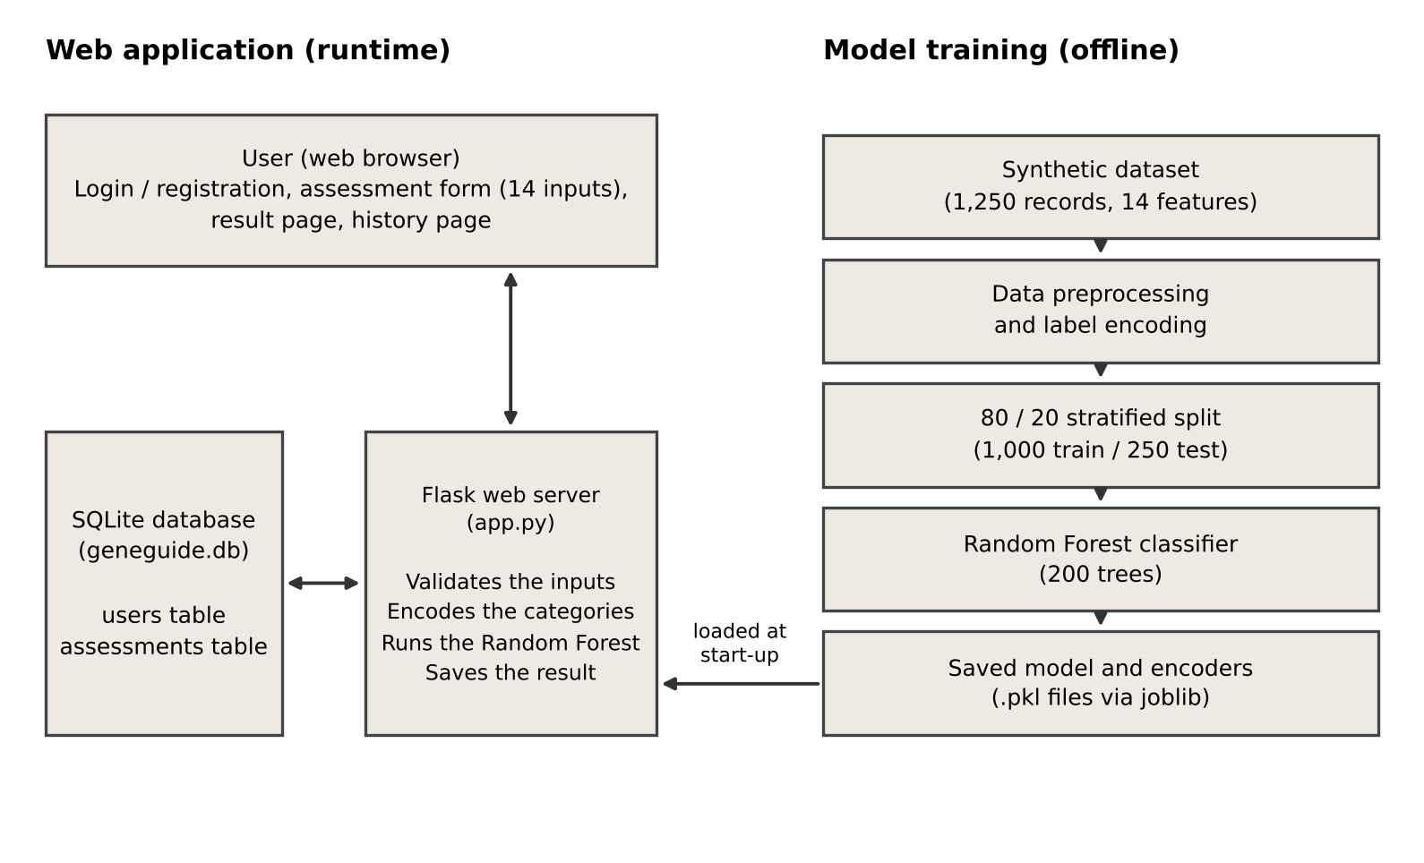
Figure 1: Proposed system architecture of GeneGuide AI
Workflow
1. A new user registers with a username and password; the password is stored only as a Werkzeug-generated hash.
2. After login, a Flask session records who the user is, and a login_required decorator limits the assessment and history pages to signed-in users.
3. When the user submits the form, the server checks the numeric ranges and encodes the categorical fields with the training encoders.
4. The Random Forest predicts the risk category, the inputs and result are saved in the assessments table, and the result page is shown.
5. The user can browse their own past assessments on the history page and log out at any time.
Database Design
Table 2: Database tables
Table | Columns | Purpose
users | id (primary key), username (unique), password hash | Stores registered accounts
assessments | id (primary key), user_id (foreign key), date_time, the 14 assessment inputs, risk_level | Stores each assessment and its predicted risk level

3.4 HARDWARE REQUIREMENTS
Table 3: Hardware requirements
Component | Requirement
Device | Laptop or desktop computer
Processor | Modern processor
RAM | 4 GB or more
Storage | Adequate free storage for the project files and database
Network | Internet connection

3.5 SOFTWARE REQUIREMENTS
Table 4: Software requirements
Software / Library | Purpose
Python | Main programming language
Flask | Web framework for the application server
Werkzeug | Password hashing and security helpers
Pandas, NumPy | Data loading and numerical operations
Scikit-learn | Label encoding, Random Forest model and evaluation metrics
Joblib | Saving and loading the trained model and encoders
Matplotlib | Plotting the confusion matrix
HTML, CSS, JavaScript | Web pages, styling and form checks
SQLite | Database for users and assessments
VS Code | Code editor
Web browser | Google Chrome or Mozilla Firefox

CHAPTER 4. IMPLEMENTATION
4.1 METHODOLOGY
This chapter explains how GeneGuide AI was built, from the dataset and the machine learning model to the web application modules. The methodology follows seven steps: dataset preparation, preprocessing, feature encoding, train-test split, model training, performance evaluation and risk classification.
Step 1: Dataset Preparation
The model is trained on a synthetic, medically informed dataset of 1,250 records. Each record has fourteen input features and one target column, Risk_Level, with the values Low, Moderate or High. Using synthetic data instead of real patient records for prototype development is an accepted practice in healthcare machine learning, largely because it avoids the privacy, consent and data-sharing limits that restrict access to clinical records [10]. The dataset is meant for prototype and educational evaluation only.
Table 5: Input features by category
Category | Features
Demographic and pregnancy (3) | Mother_Age, Father_Age, Pregnancy_Week
Family history (4) | Family_History, Number_of_Affected_Family_Members, Type_of_Family_History, Carrier_Status
Genetic testing and obstetric history (7) | Parental_Genetic_Test_Result, Previous_Child_Genetic_Disorder, Previous_Abnormal_Pregnancy, Consanguineous_Marriage, Previous_Miscarriages, Multiple_Pregnancy, Previous_Prenatal_Screening

The class distribution leans towards the Moderate category: 650 records (52.0%) are Moderate, 315 (25.2%) are High and 285 (22.8%) are Low.
Table 6: Class distribution
Risk_Level | Records | Share
Low | 285 | 22.8%
Moderate | 650 | 52.0%
High | 315 | 25.2%

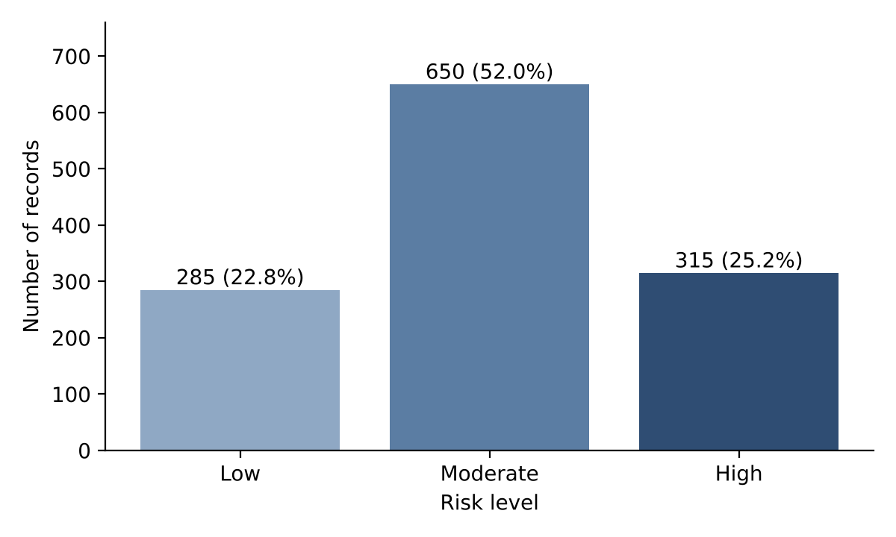
Figure 2: Class distribution of the dataset
Step 2: Data Preprocessing
Numeric fields (maternal and paternal age, pregnancy week, number of affected family members and previous miscarriages) go into the model as they are, and each is also bounded separately by the web form’s input validation. One detail matters during loading: several categorical fields use the literal text value "None" to mean that a condition is absent, and common data-loading libraries can silently read this text as a missing value. The dataset is therefore loaded with keep_default_na=False so that "None" stays a real category.
Step 3: Feature Encoding
Nine of the fourteen input features are categorical. Each is converted with its own scikit-learn LabelEncoder [7]. The same encoders are saved with joblib and reused at prediction time, so a category maps to the same integer in training and in live use. The target column has a separate LabelEncoder, and predictions are converted back to a Low, Moderate or High label.
Step 4: Train-Test Split
The dataset is divided 80/20 into 1,000 training records and 250 test records, using a fixed random state of 42 and stratifying on the target column so both splits keep the Low, Moderate and High proportions. The model is fitted on the training split only.
Step 5: Model Training – Random Forest
A RandomForestClassifier [7] with 200 estimators and a random state of 42 is the classification model of the system. It follows the ensemble-of-decision-trees approach first described by Breiman [6]. Random Forest was chosen because it handles tabular data that mixes categorical and numeric features, it resists overfitting better than a single decision tree, and it can later expose feature importances for explainability.
Step 6: Performance Evaluation
The trained model predicts the 250 unseen test records. Accuracy, precision, recall, F1-score and the confusion matrix are calculated with Scikit-learn. These results are reported in Section 5.4.
Step 7: Risk Classification
At prediction time the fourteen validated form inputs are placed in a single-row table, the categorical columns are transformed with the saved encoders, and the Random Forest predicts a class that is converted back to Low, Moderate or High.
4.2 IMPLEMENTATION OF MODULES
The web application is a single-file Flask application with six Jinja2 templates: home, login, registration, assessment, result and history pages, and one CSS file for styling. It is divided into the following modules.
4.2.1 Authentication Module
Registration hashes the submitted password with Werkzeug’s generate_password_hash before inserting it into SQLite. Login checks the password with check_password_hash against the stored hash, so plain-text passwords are never stored or compared. After a successful login, a Flask session records the user. A login_required decorator on the assessment, prediction and history routes redirects unauthenticated requests to the login page, and logging out clears the session.
4.2.2 Assessment Form Module
The assessment page holds the fourteen-field form, split into three sections: basic information, family history, and genetic and pregnancy information. A small JavaScript file keeps the family-history choice in sync with the type-of-family-history dropdown, so a user who reports no family history is steered to the matching "None" category and does not end up with an inconsistent combination.
4.2.3 Risk Prediction Module
The prediction route first checks that the numeric fields fall within plausible ranges:
Table 7: Input range checks
Field | Allowed range
Mother’s age | 18 to 45
Father’s age | 20 to 55
Pregnancy week | 8 to 40
Affected family members | 0 to 3
Previous miscarriages | 0 to 3

If a field is missing or outside its range, the route returns a descriptive error so the model never receives unvalidated input. Once the inputs pass, the module builds the feature table, applies the saved label encoders, gets a prediction from the Random Forest and stores the assessment and its predicted risk level in the database.
4.2.4 Result Module
The result page shows the predicted risk level (Low, Moderate or High), an explanation of why the result may have occurred, and a medical disclaimer that describes the output as an educational risk category and not a medical conclusion. It encourages the user to see a qualified healthcare professional.
4.2.5 History Module
Every assessment is saved in the assessments table. The history page lists the logged-in user’s past assessments, and every query is filtered by that user’s id, so one user’s history is never visible to another. All SQL statements use parameterized queries, which avoids SQL-injection risk.
CHAPTER 5. CONCLUSION AND FUTURE WORK
5.1 CONCLUSION
This project presented GeneGuide AI, a Flask-based prototype for prenatal genetic risk assessment and decision support, driven by a Random Forest classifier. The system takes fourteen prenatal, family-history and genetic inputs, classifies the case as Low, Moderate or High risk, explains the result and keeps a private history for every user.
On a held-out test set of 250 records the model reached 85.2% accuracy. Low-risk cases were predicted best (F1-score 0.92), Moderate-risk cases were recalled most often (recall 0.92), and High-risk cases had the lowest recall (0.67). Importantly, the model never confused Low risk with High risk: when it was wrong, it fell into the neighbouring Moderate category. This is a reassuring failure pattern for a decision-support tool.
GeneGuide AI is deliberately scoped as an educational prototype. It uses a synthetic dataset, has not been clinically validated, and presents its output strictly as an AI-generated risk category and not a diagnosis, pointing users to professional medical advice. Within that scope it shows how machine learning and a simple web interface can make early risk screening more accessible.
5.2 FUTURE WORK
• Model comparison: compare Random Forest with other models such as Logistic Regression and Decision Tree on the same dataset.
• Cross-validation: add k-fold cross-validation for a more robust estimate of performance.
• Better data: use more real-world and diverse data with proper clinical validation, and a more balanced class distribution.
• Explainability: compute and display feature importances and evaluate explanation methods such as LIME and SHAP [12], so that each result shows the inputs that influenced it most.
• High-risk detection: improve recall for the High-risk class and give clearer model explanations.
• Dashboard: add a dashboard that tracks a user’s assessments over time, with counts by risk level.
5.3 SOURCE CODE
A. Web Application (app.py)
The following Flask program (app.py) loads the saved model and encoders, creates the SQLite database, and provides the routes for registration, login, assessment, prediction, history and logout.
from flask import Flask, render_template, request, redirect, url_for, session
import pandas as pd
import joblib
import sqlite3
from datetime import datetime
from functools import wraps
from werkzeug.security import generate_password_hash, check_password_hash
app = Flask(__name__)
# Secret key for login session
app.secret_key = "geneguide_secret_key"
# =========================================================
# LOAD AI MODEL
model = joblib.load("model/random_forest_model.pkl")
label_encoders = joblib.load("model/label_encoders.pkl")
target_encoder = joblib.load("model/target_encoder.pkl")

# =========================================================
# CREATE DATABASE
def create_database():
connection = sqlite3.connect("geneguide.db")
cursor = connection.cursor()
# Users table
cursor.execute("""
CREATE TABLE IF NOT EXISTS users (
id INTEGER PRIMARY KEY AUTOINCREMENT,
username TEXT UNIQUE NOT NULL,
password TEXT NOT NULL
)
""")

# Assessment history table
cursor.execute("""
CREATE TABLE IF NOT EXISTS assessments (
id INTEGER PRIMARY KEY AUTOINCREMENT,
user_id INTEGER NOT NULL,
date_time TEXT,
mother_age INTEGER,
father_age INTEGER,
pregnancy_week INTEGER,

family_history TEXT,
affected_family_members INTEGER,
family_history_type TEXT,

carrier_status TEXT,
genetic_test_result TEXT,

previous_child_disorder TEXT,
previous_abnormal_pregnancy TEXT,

consanguineous_marriage TEXT,
previous_miscarriages INTEGER,

multiple_pregnancy TEXT,
previous_prenatal_screening TEXT,

risk_level TEXT,
FOREIGN KEY (user_id) REFERENCES users(id)
)
""")
connection.commit()
connection.close()

# Run database creation automatically
create_database()

# =========================================================
# LOGIN REQUIRED FUNCTION

def login_required(function):
@wraps(function)
def decorated_function(*args, **kwargs):
if "user_id" not in session:
return redirect(url_for("login"))
return function(*args, **kwargs)
return decorated_function
# =========================================================
# HOME PAGE

@app.route("/")
def home():

return render_template("index.html")
# =========================================================
# REGISTER

@app.route("/register", methods=["GET", "POST"])
def register():
if request.method == "POST":
username = request.form["username"].strip()
password = request.form["password"]
# Check empty fields
if not username or not password:
return "Username and password are required."
# Hash password
hashed_password = generate_password_hash(password)
connection = sqlite3.connect("geneguide.db")
cursor = connection.cursor()
try:
cursor.execute(
"""
INSERT INTO users (username, password)
VALUES (?, ?)
""",
(username, hashed_password)
)
connection.commit()
except sqlite3.IntegrityError:
connection.close()

return "Username already exists. Please choose another."

connection.close()
return redirect(url_for("login"))
return render_template("register.html")
# =========================================================
# LOGIN

@app.route("/login", methods=["GET", "POST"])
def login():
if request.method == "POST":
username = request.form["username"].strip()
password = request.form["password"]
connection = sqlite3.connect("geneguide.db")
connection.row_factory = sqlite3.Row
cursor = connection.cursor()
cursor.execute(
"""
SELECT *
FROM users
WHERE username = ?
""",
(username,)
)

user = cursor.fetchone()
connection.close()
# Check username and password
if user and check_password_hash(user["password"], password):
session["user_id"] = user["id"]
session["username"] = user["username"]
return redirect(url_for("assessment"))

return "Invalid username or password."
return render_template("login.html")

# =========================================================
# LOGOUT
@app.route("/logout")
def logout():
session.clear()
return redirect(url_for("home"))

# =========================================================
# ASSESSMENT PAGE

@app.route("/assessment")
@login_required
def assessment():
return render_template("assessment.html")

# =========================================================
# PREDICTION
@app.route("/predict", methods=["POST"])
@login_required
def predict():
try:
mother_age = int(
request.form["Mother_Age"]
)

father_age = int(
request.form["Father_Age"]
)

pregnancy_week = int(
request.form["Pregnancy_Week"]
)

affected_members = int(
request.form[
"Number_of_Affected_Family_Members"
]
)

miscarriages = int(
request.form["Previous_Miscarriages"]
)

# -------------------------------------------------
# INPUT VALIDATION
if not 18 <= mother_age <= 45:

return "Invalid Mother Age. Please enter a value between 18 and 45."

if not 20 <= father_age <= 55:
return "Invalid Father Age. Please enter a value between 20 and 55."

if not 8 <= pregnancy_week <= 40:
return "Invalid Pregnancy Week. Please enter a value between 8 and 40."

if not 0 <= affected_members <= 3:
return "Invalid number of affected family members. Please enter a value between 0 and 3."

if not 0 <= miscarriages <= 3:
return "Invalid number of previous miscarriages. Please enter a value between 0 and 3."

# -------------------------------------------------
# GET CATEGORICAL VALUES
input_data = {

"Mother_Age":
mother_age,

"Father_Age":
father_age,

"Pregnancy_Week":
pregnancy_week,

"Family_History":
request.form["Family_History"],

"Number_of_Affected_Family_Members":
affected_members,

"Type_of_Family_History":
request.form.get("Type_of_Family_History", "None"),

"Carrier_Status":
request.form["Carrier_Status"],

"Parental_Genetic_Test_Result":
request.form["Parental_Genetic_Test_Result"],

"Previous_Child_Genetic_Disorder":
request.form["Previous_Child_Genetic_Disorder"],

"Previous_Abnormal_Pregnancy":
request.form["Previous_Abnormal_Pregnancy"],

"Consanguineous_Marriage":
request.form["Consanguineous_Marriage"],

"Previous_Miscarriages":
miscarriages,

"Multiple_Pregnancy":
request.form["Multiple_Pregnancy"],

"Previous_Prenatal_Screening":
request.form["Previous_Prenatal_Screening"]
}

# -------------------------------------------------
# CONVERT TO DATAFRAME

df = pd.DataFrame([input_data])

# -------------------------------------------------
# ENCODE CATEGORICAL VALUES

for column, encoder in label_encoders.items():
df[column] = encoder.transform(
df[column]
)

# -------------------------------------------------
# AI PREDICTION

prediction = model.predict(df)
# Convert prediction back to text
risk_level = target_encoder.inverse_transform(
prediction
)[0]

# -------------------------------------------------
# SAVE ASSESSMENT HISTORY
connection = sqlite3.connect("geneguide.db")
cursor = connection.cursor()
cursor.execute(
"""
INSERT INTO assessments (
user_id,
date_time,

mother_age,
father_age,
pregnancy_week,

family_history,
affected_family_members,
family_history_type,

carrier_status,
genetic_test_result,

previous_child_disorder,
previous_abnormal_pregnancy,

consanguineous_marriage,
previous_miscarriages,

multiple_pregnancy,
previous_prenatal_screening,

risk_level
)

VALUES (?, ?, ?, ?, ?, ?, ?, ?, ?, ?, ?, ?, ?, ?, ?, ?, ?)

""",

(

session["user_id"],
datetime.now().strftime(
"%Y-%m-%d %H:%M:%S"
),

mother_age,
father_age,
pregnancy_week,

input_data["Family_History"],

affected_members,

input_data[
"Type_of_Family_History"
],

input_data[
"Carrier_Status"
],

input_data[
"Parental_Genetic_Test_Result"
],

input_data[
"Previous_Child_Genetic_Disorder"
],

input_data[
"Previous_Abnormal_Pregnancy"
],

input_data[
"Consanguineous_Marriage"
],

miscarriages,

input_data[
"Multiple_Pregnancy"
],

input_data[
"Previous_Prenatal_Screening"
],

risk_level
)
)

connection.commit()
connection.close()

# -------------------------------------------------
# SHOW RESULT

return render_template(
"result.html",
risk_level=risk_level
)
except ValueError:
return "Invalid input. Please enter valid numbers."

except KeyError as e:
return f"Missing required field: {e}"

except Exception as e:
return f"Error processing assessment: {e}"

# =========================================================
# HISTORY

@app.route("/history")
@login_required
def history():

connection = sqlite3.connect("geneguide.db")

connection.row_factory = sqlite3.Row

cursor = connection.cursor()

cursor.execute(
"""
SELECT *
FROM assessments

WHERE user_id = ?

ORDER BY id DESC
""",
(session["user_id"],)
)

assessments = cursor.fetchall()

connection.close()

return render_template(
"history.html",
assessments=assessments
)

# =========================================================
# RUN FLASK APPLICATION
# =========================================================

if __name__ == "__main__":

app.run(debug=True)
5.4 RESULTS
Model Performance
On the 250-record held-out test split, the Random Forest model reaches an overall accuracy of 85.2%. The per-class results are given in Table 8.
Table 8: Per-class classification report
Class | Precision | Recall | F1-score | Support
Low | 0.93 | 0.91 | 0.92 | 57
Moderate | 0.82 | 0.92 | 0.87 | 130
High | 0.86 | 0.67 | 0.75 | 63

Low-risk cases show the best balance of precision and recall. Moderate-risk cases, the majority class, are recalled most often (0.92) with somewhat lower precision (0.82). High-risk cases have the lowest recall (0.67) despite fairly high precision (0.86): when the model predicts High risk it is usually right, but it misses a share of the real High-risk cases.
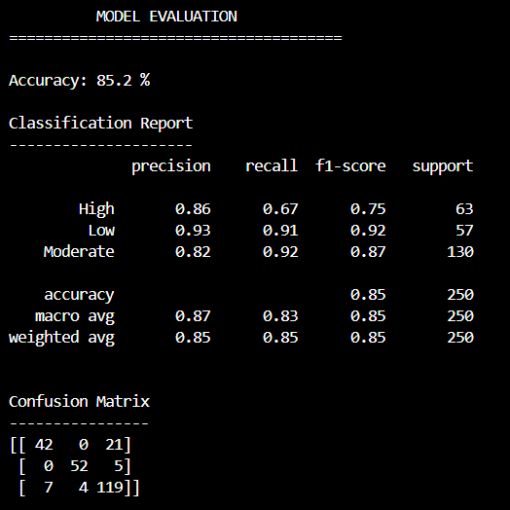
Figure 3: Training output (accuracy, classification report, confusion matrix)
Confusion Matrix
Table 9: Confusion matrix (rows = actual, columns = predicted)
Actual \ Predicted | High | Low | Moderate
High | 42 | 0 | 21
Low | 0 | 52 | 5
Moderate | 7 | 4 | 119

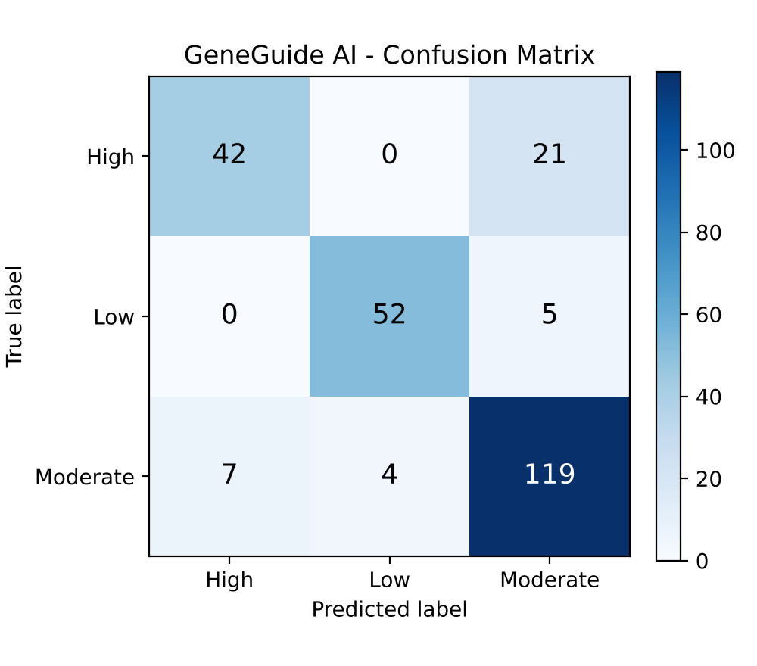
Figure 4: Confusion matrix on the 250-record test set
The matrix shows that the model never mixes up High and Low risk in either direction. The largest single source of error is the 21 truly High-risk cases predicted as Moderate, which accounts for most of the shortfall in High-risk recall. A smaller pattern is also visible: 7 Moderate cases were predicted as High and 4 as Low. With only 1,250 records, the dataset puts a natural ceiling on how finely the boundary between High and Moderate risk can be learned.
Application Output
The screenshots below show the working GeneGuide AI web application.
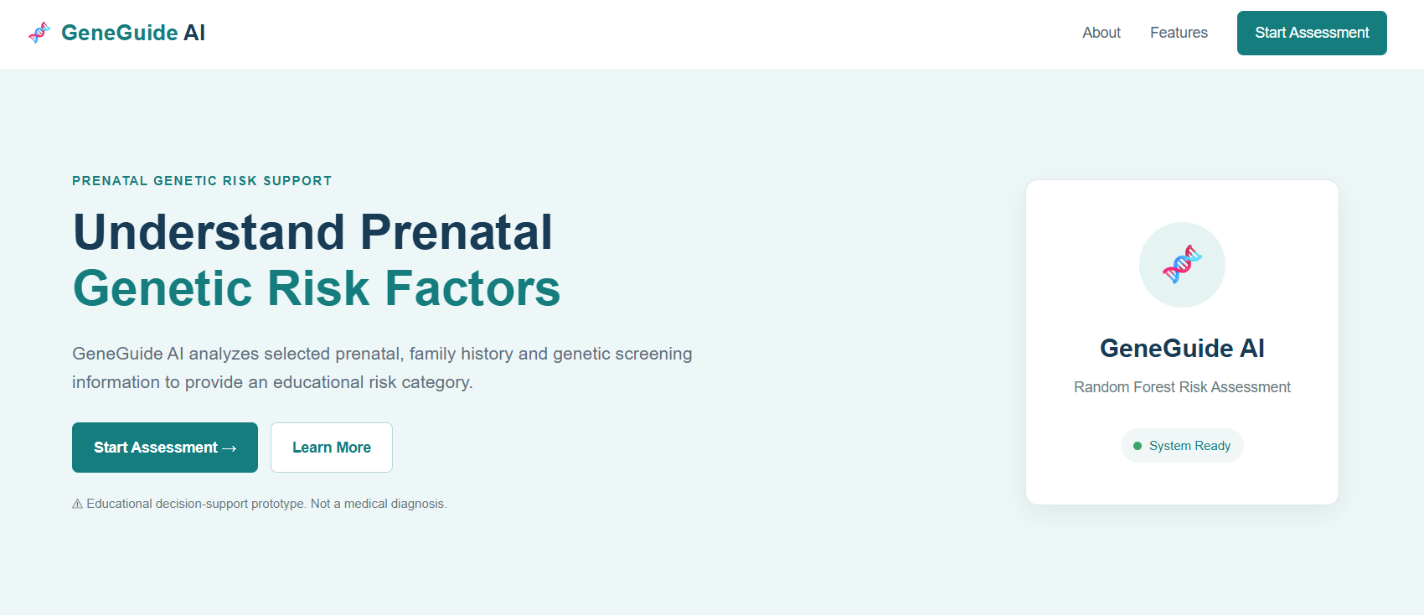
Figure 5: Home page of GeneGuide AI
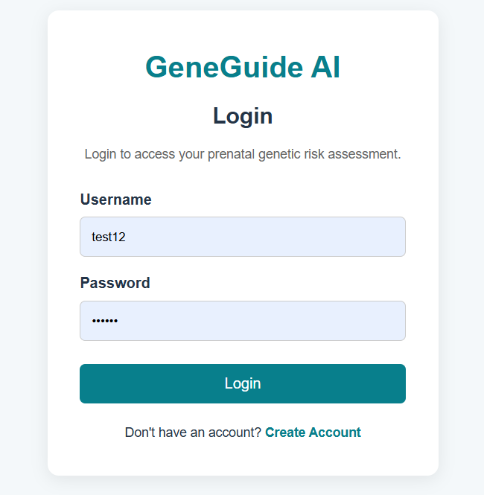
Figure 6: Login page
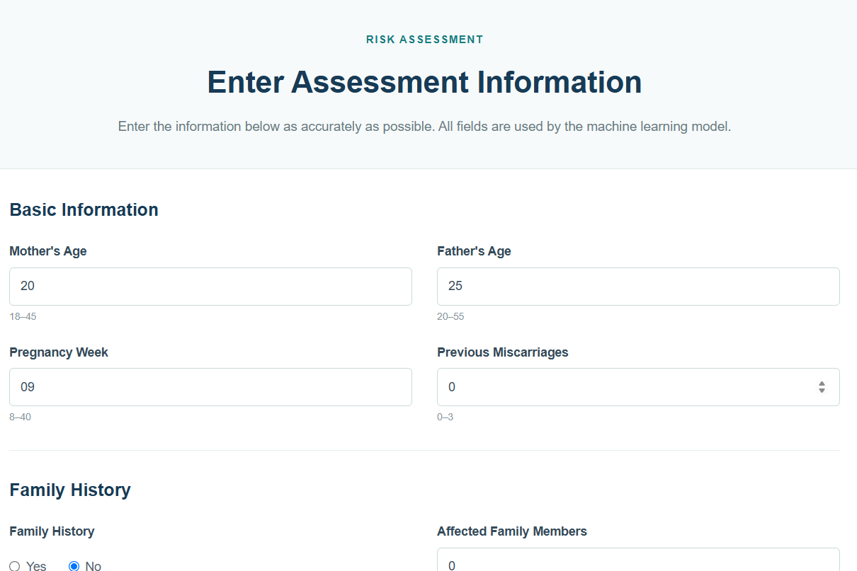
Figure 7: Assessment form
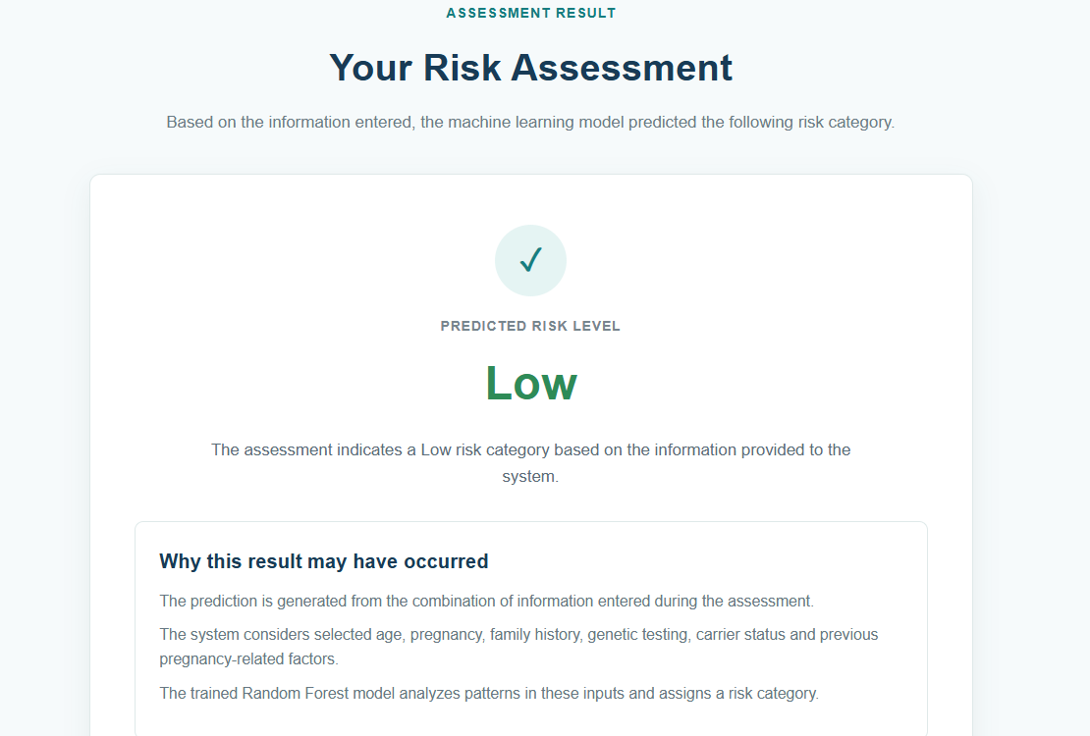
Figure 8: Result page
The home page introduces the project and states that it is an educational prototype and not a medical diagnosis. The assessment form has three sections: basic information, family history, and genetic and pregnancy details. The result page shows the predicted risk level (here: Low) and why the result may have occurred.
Note: GeneGuide AI is an educational prototype trained on synthetic data. Its output is not a medical diagnosis.
APPENDIX A- CONFERENCE PAPER CERTIFICATE

Certificate 1 – Mohamed Ismail
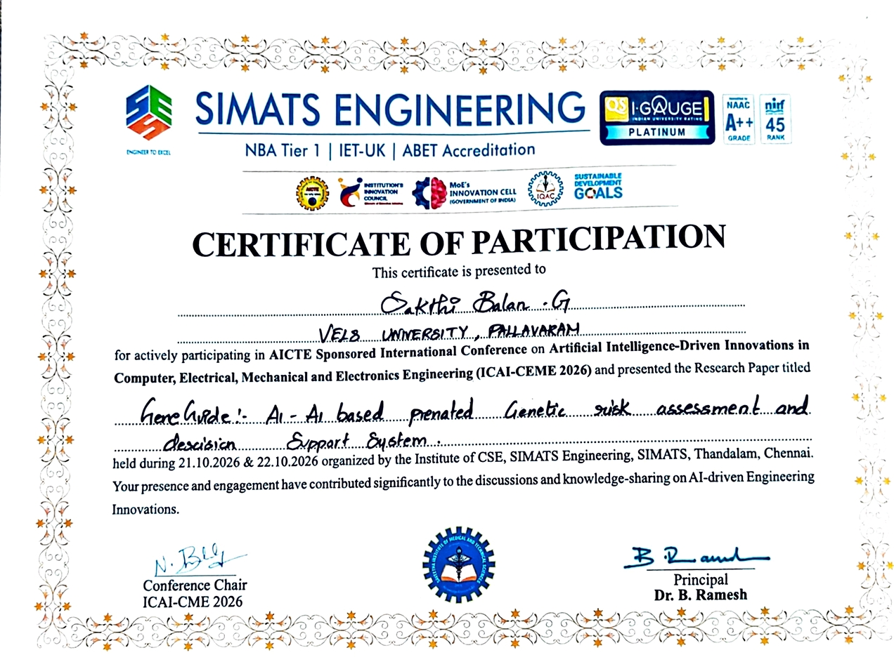
Certificate 2- Sakthibalan G

Certificate 3- Veerapuvin S
REFERENCES
[1] X. Yuan, C. Wang, S. Zhu, and L. Zhang, “DBNX: A Machine Learning Method for Ensembling Polygenic Risk Scores and Non-Genetic Factors,” IEEE Trans. Computational Biology and Bioinformatics, vol. 22, no. 5, pp. 2031–2042, Sep./Oct. 2025.
[2] A. C. Neocleous, K. H. Nicolaides, and C. N. Schizas, “First Trimester Noninvasive Prenatal Diagnosis: A Computational Intelligence Approach,” IEEE J. Biomedical and Health Informatics, vol. 20, no. 5, pp. 1427–1438, Sep. 2016.
[3] A. C. Neocleous, K. H. Nicolaides, and C. N. Schizas, “Intelligent Noninvasive Diagnosis of Aneuploidy: Raw Values and Highly Imbalanced Dataset,” IEEE J. Biomedical and Health Informatics, vol. 21, no. 5, pp. 1271–1279, Sep. 2017.
[4] L. Li, W. Liu, H. Zhang, Y. Jiang, X. Hu, and R. Liu, “Down Syndrome Prediction Using a Cascaded Machine Learning Framework Designed for Imbalanced and Feature-correlated Data,” IEEE Access, 2019, doi: 10.1109/ACCESS.2019.2929681.
[5] Y. Salini, S. N. Mohanty, J. V. N. Ramesh, M. Yang, and M. M. V. Chalapathi, “Cardiotocography Data Analysis for Fetal Health Classification Using Machine Learning Models,” IEEE Access, 2024, doi: 10.1109/ACCESS.2024.3364755.
[6] L. Breiman, “Random Forests,” Machine Learning, vol. 45, no. 1, pp. 5–32, 2001.
[7] F. Pedregosa et al., “Scikit-learn: Machine Learning in Python,” Journal of Machine Learning Research, vol. 12, pp. 2825–2830, 2011.
[8] N. V. Chawla, K. W. Bowyer, L. O. Hall, and W. P. Kegelmeyer, “SMOTE: Synthetic Minority Over-sampling Technique,” Journal of Artificial Intelligence Research, vol. 16, pp. 321–357, 2002.
[9] A. P. Susanto, D. Lyell, B. Widyantoro, S. Berkovsky, and F. Magrabi, “Effects of Machine Learning-Based Clinical Decision Support Systems on Decision-Making, Care Delivery, and Patient Outcomes: A Scoping Review,” Journal of the American Medical Informatics Association, vol. 30, no. 12, pp. 2050–2063, Dec. 2023.
[10] A. Gonzales, G. Guruswamy, and S. R. Smith, “Synthetic Data in Health Care: A Narrative Review,” PLOS Digital Health, vol. 2, no. 1, e0000082, 2023.
[11] Š. Miroševič, Z. Klemenc-Ketiš, and B. Peterlin, “Family History Tools for Primary Care: A Systematic Review,” European Journal of General Practice, vol. 28, no. 1, pp. 75–86, 2022.
[12] M. Panda and S. R. Mahanta, “Explainable Artificial Intelligence for Healthcare Applications Using Random Forest Classifier with LIME and SHAP,” arXiv:2311.05665, 2023.

